Improving the Performance of Long-Term Stock Investments with a Two-Stage LLM Filtering Framework
Jathin Battepati, Rohan Fernandes, Aaryan Parikh, Sahasra Chappidi, Sanil Nirmale, Simran Bhasin, Simran Chhabria, Rohan Sugate, Dr. Huifang Qin

Abstract
Driven by the rapid progress of Large Language Models (LLMs) such as ChatGPT, Gemini, and Claude, researchers are increasingly exploring AI-driven investment strategies. Previous research into LLM-driven investing often relies on the simultaneous ingestion of multiple information sources, an approach that can introduce noise and dilute relevant signals. To address this limitation, we developed a two-stage sequential filtering framework in which news articles are first analyzed to identify candidate stocks and financial reports are subsequently used to validate and refine those selections. Using 2,759 portfolio runs across multiple models, temperatures, filtering configurations, and evaluation windows, we find that filtering that only eliminates a moderate number of companies between steps consistently outperforms the unfiltered single-pass methodology while also outperforming the S&P 500 benchmark. Focusing on the strongest model, GPT-5.1, the best configuration, which proposes twenty candidate stocks and narrows them to a ten-stock portfolio, achieved the highest mean ROI (60.6%) and beat the unfiltered baseline in 81.5% of matched evaluation windows. The other moderately filtered configurations — those that keep a mid-sized candidate pool and roughly halve it between stages — beat that baseline in about three of every four windows as well. Across all configurations GPT-5.1 outperformed the S&P 500 in 96.5% of runs. The unfiltered baseline also beat the S&P 500, however, so this market advantage reflects model and sector strength rather than the filtering; the filtering’s specific contribution is its gain over that baseline — up to 15 percentage points of additional mean ROI (60.6% versus 45.7%). These findings suggest that structural organization of information is a critical component of LLM-based investment systems and can significantly improve long-term investment performance.

1 Introduction

1.1 Background and Motivation
Robust financial analysis requires integrating qualitative sentiment—extracted from earnings reports and news sources—with quantitative metrics such as historical price, volume, and risk profiles [1]. Capitalising on their natural language understanding capabilities, LLMs are increasingly applied to financial markets to generate directional signals—buy, hold, or sell recommendations—by synthesising information from news, earnings reports, and regulatory filings [2][24][37].
The bulk of existing LLM-based investment research focuses on short-term trading horizons—high-frequency trading or single-day price prediction [2][24][37]. A growing subset of work has begun exploring longer horizons [3][20], but this literature remains limited in scope: most studies do not guard against lookahead bias by restricting the model to information available at the simulated investment date, and few target holding periods exceeding one quarter. Long-term investing, by contrast, demands sustained reasoning over extended horizons—a domain traditionally reserved for human analysts who synthesise broad macroeconomic insights, qualitative judgment, and multi-year strategic perspectives [3]. This gap motivates the present work: we investigate whether a structured LLM pipeline can generate reliable investment strategies over 12-month holding periods under conditions a real investor could reproduce, using only information available at the time of each decision and avoiding any look-ahead into future data.

1.2 Current Challenges
Several key limitations constrain the use of LLMs in investment contexts. A primary concern is their documented inability to perform reliable numerical computation [4]. Studies have demonstrated that LLMs exhibit systematic arithmetic errors, limiting their utility for quantitative tasks that require precise calculation. As a result, LLMs cannot replace the role of the experienced human analyst, whose investment judgments are grounded in rigorous financial modelling and quantitative reasoning.
A second challenge is hallucination: LLMs can fabricate or misrepresent information with high apparent confidence [5]. In an investment context, this can result in recommendations based on non-existent corporate events, incorrect financial figures, or wholly invented analyst reports. Critically, hallucinations are not always overt. Subtle hallucinations—small distortions in attributed facts, misremembered statistics, or plausible-sounding but inaccurate characterizations of company performance—may pass undetected and propagate systematically through the recommendation pipeline, making them particularly dangerous for investment applications where errors in reasoning compound over a holding period.
A third challenge is implicit bias introduced through LLM pre-training. Because modern LLMs are trained on large corpora with a fixed knowledge cutoff, they may encode implicit awareness of future events relative to any historical analysis date, effectively providing look-ahead information that no real investor could possess at the time of decision-making. This form of data leakage is particularly problematic for backtesting: strategies that appear profitable in retrospective evaluation may be artifacts of the model’s latent knowledge of subsequent market developments rather than genuine analytical insight, casting doubt on the validity of reported results.

1.3 Contributions
This paper proposes a two-stage structured pipeline for generating reliable long-term investment strategies with large language models. The framework decomposes the investment task into two sequential stages: a news-based candidate selection stage, in which the LLM identifies a set of candidate stocks from a curated set of financial news articles; and a financial report validation stage, in which the LLM reads company financial reports for each candidate and produces a smaller, higher-conviction final portfolio. This sequential evaluation of information sources—rather than simultaneous ingestion—constitutes the central methodological contribution of this work.
The framework is designed to address all three challenges identified above. By decomposing the task into stages, the pipeline constrains each stage to a well-defined subtask, reducing the opportunity for hallucination and improving output consistency. Strict temporal boundaries prevent any form of look-ahead information leakage. And by delegating all numerical computation to deterministic external modules, the framework avoids reliance on LLM arithmetic—a known source of unreliable outputs.
In summary, this paper delivers three primary contributions:
- A novel two-stage news-and-financial-report architecture for LLM-driven long-term investment strategy generation, featuring a principled separation of qualitative and quantitative reasoning that measurably improves deployment consistency.
- Extensive empirical validation centered on advanced frontier models, demonstrating that moderate filtering configurations — those that keep a mid-sized candidate pool and roughly halve it between stages — achieve a mean ROI of up to 60.6%, outperform the unfiltered baseline in 74–82% of matched evaluation windows — the range spans the four well-sized configurations — and beat the S&P 500 benchmark in 96.5% of runs.
- A systematic sensitivity analysis of returns and consistency across ten distinct pipeline configurations. This analysis establishes that while moderate filtering consistently improves upon single-pass methodologies, aggressive over-filtering — forcing the model to draw from an oversized candidate pool it cannot fill with strong companies — degrades performance. Furthermore, we demonstrate that the optimal filtering threshold is model-dependent and that, for any target portfolio size, the ideal configuration requires a Stage One candidate pool roughly twice that size.

2 Prior Work
Large language models have emerged as transformative tools in the financial industry. Their capacity for automation tasks—including summarization [25], information extraction, and natural language generation—makes them well-suited for applications such as market trend monitoring, risk factor identification, and investment decision support [1]. As LLMs have scaled in both parameter count and training data, their ability to process complex, heterogeneous financial datasets has grown substantially [2]. This increased capability, however, introduces interpretability challenges: the opacity of large models makes it difficult to audit whether their outputs reflect genuine financial reasoning or spurious correlations embedded during pre-training [3]. Because undetected biases in LLM outputs can propagate into consequential financial decisions, practitioners must apply these models with rigor and appropriate safeguards [4]. Despite these inherent risks, the rapid evolution of Large Language Models (LLMs) possesses the potential to fundamentally reshape financial analysis. Realizing this potential, however, depends entirely on implementing clear, principled frameworks to guide their deployment [5].

2.1 Large Language Models in Financial Forecasting
Existing research work has demonstrated the proficiency of LLMs in synthesizing heterogeneous financial data to extract predictive market signals [6][7][8]. Studies integrating LLMs with conventional forecasting techniques reported improved predictive accuracy, attributed to the models’ ability to capture nuanced relationships between news sentiment and price movements [9][10][11]. A complementary line of work combines document embeddings with LLM-generated representations to construct richer proxies for investor sentiment and macroeconomic conditions [6][7]. By automating the extraction of financially relevant signals from unstructured text, LLMs reduce the manual overhead of information processing and enable more scalable financial modelling pipelines [8][9]. Researchers have further combined LLMs with established quantitative frameworks—for example, integrating LLM-generated sentiment scores with LSTM networks and Black-Litterman portfolio optimization models—and report performance improvements over conventional approaches alone.

2.2 Multi-Agent LLM Systems for Trading
Beyond single-model deployments, LLMs are increasingly employed as components of multi-agent trading systems, in which specialized agents interact to simulate market dynamics and refine portfolio strategies [12][13][14][26]. Such systems incorporate layered memory architectures and role-differentiated agent designs, enabling individual agents to retain relevant historical context and adapt their behavior as market conditions evolve [15][16]. Empirical evidence indicates that multi-agent configurations frequently outperform single-agent baselines, as the diversity of strategies across agents reduces overfitting observed in isolated backtests [17][18]. Within these architectures, individual agents are assigned distinct functions—portfolio allocation, risk assessment, and real-time monitoring—enabling a modular division of responsibilities that exploits the natural language flexibility of LLMs [12][19]. Representative frameworks such as 3S-Trader [45], AlphaAgents [43], FinRobot [44], and tool-augmented multimodal foundation agents [41] coordinate multiple LLMs to score candidate stocks, construct a portfolio, and iteratively refine strategies from historical performance weekly, though at the cost of considerable system complexity.

2.3 Sentiment Analysis and Market Dynamics
LLMs have proven adept at inferring investor sentiment and forecasting market movements by analyzing news articles and social media data [20][21][22]. By leveraging pre-training on large-scale financial datasets, LLMs can discern specialized terminology and complex rhetorical structures, providing an effective framework for mapping textual information to market price movements [23][24]. Sentiment-augmented models have been shown to identify early indicators of trend reversals, offering potential informational advantages for trading decisions. By processing vast quantities of unstructured data at scale, LLMs enable the development of more agile, information-rich trading strategies that respond to market shifts in real time [27][28][29]. This body of research extends foundational work by demonstrating that media-derived content yields quantifiable sentiment signals that have a direct and measurable impact on equity prices [4].

2.4 Reinforcement Learning and Financial LLMs
The integration of LLMs with reinforcement learning (RL) has produced further gains in automated trading performance [30][31][32]. RL-augmented systems enable continuous strategy refinement through feedback from simulated or live market interactions, allowing the model to update its decision policy as conditions change [33][34]. By framing portfolio management as a sequential decision problem, RL provides a principled mechanism for balancing exploration of new strategies against exploitation of established ones, improving risk-adjusted returns [35][36]. This adaptive capacity makes RL-LLM systems particularly well-suited to environments characterized by non-stationary dynamics and heterogeneous market regimes [37][38][39].

2.5 Benchmarks, Evaluation, and Bias
Systematic benchmarking provides a principled basis for evaluating the capabilities and limitations of financial LLMs [40][12][14]. Standardized evaluation datasets enable rigorous comparisons across models and multi-agent systems along dimensions including textual comprehension, sentiment extraction, and portfolio optimization [15][16][19]. A consistent finding is that testing a model for its accuracy is not enough — it must also be shown to perform reliably under the pressures and limitations of a live market [18][20][21]. Ongoing investment in benchmark development is therefore essential to ensure that reported advances reflect genuine improvements rather than artefacts of narrow or favorable evaluation conditions [22][23][24].
A critical concern in this literature is evaluation bias. A 2025 study by Li et al. created a rigorous testing framework called FINSABER to address three common problems: survivorship bias (testing only on currently successful stocks), look-ahead bias (accidentally using future information in past decisions), and data-snooping bias (testing a strategy repeatedly on the same data until favourable results arise by chance). When they re-tested popular LLM strategies over 20 years across a wider range of stocks, the strategies' apparent advantages either disappeared or appeared much weaker. The study also found that LLM strategies often performed poorly in different market conditions — too cautious during bull markets and overly aggressive during bear markets. This highlights the need for long-term, rigorous testing and strategies that can adapt to changing market conditions.
Collectively, these studies demonstrate that LLMs can generate competitive investment strategies, but they primarily focus on improving model capability through larger architectures, multi-agent systems, reinforcement learning, or sentiment extraction techniques. Comparatively little attention has been given to the structural architecture of information delivery. Because most existing approaches ingest heterogeneous sources simultaneously, it remains unclear how alternative information frameworks might optimize investment performance. This gap motivates the central question of this study: can restructuring the information flow presented to an LLM systematically improve long-term investment decision-making?

2.6 Our Project
This study addresses two distinct gaps in the existing literature, both of which are intrinsically tied to the challenges outlined in Section 1.2. First, long-term LLM investment strategies remain underexplored relative to their short-term counterparts, leaving open the question of whether LLMs can sustain reliable performance over multi-month horizons. Second, existing approaches typically rely on the simultaneous ingestion of heterogeneous information sources, creating the potential for signal dilution, information overload, and inconsistent decision-making.
To address these limitations, we propose a two-stage sequential filtering framework in which news articles and financial reports are evaluated separately rather than simultaneously. In the first stage, the model analyzes historical news articles to identify candidate investment opportunities. In the second stage, financial reports are used to validate and refine those candidates before constructing a final portfolio. This structured decomposition constrains the model to a well-defined reasoning task at each stage, allowing us to directly evaluate the impact of structural organization of information on investment performance.
The evaluation enforces strict temporal constraints at every stage to eliminate the look-ahead and data-snooping biases identified by Li et al. (2025) and others. All input data—news articles and financial reports alike—are sourced from dates strictly preceding each evaluation window. Additionally, model-specific training-cutoff restrictions were applied to reduce the possibility of lookahead bias influencing our results. These safeguards ensure that reported performance reflects genuine analytical capability rather than latent knowledge of subsequent market events embedded during LLM pre-training.

3 Methodology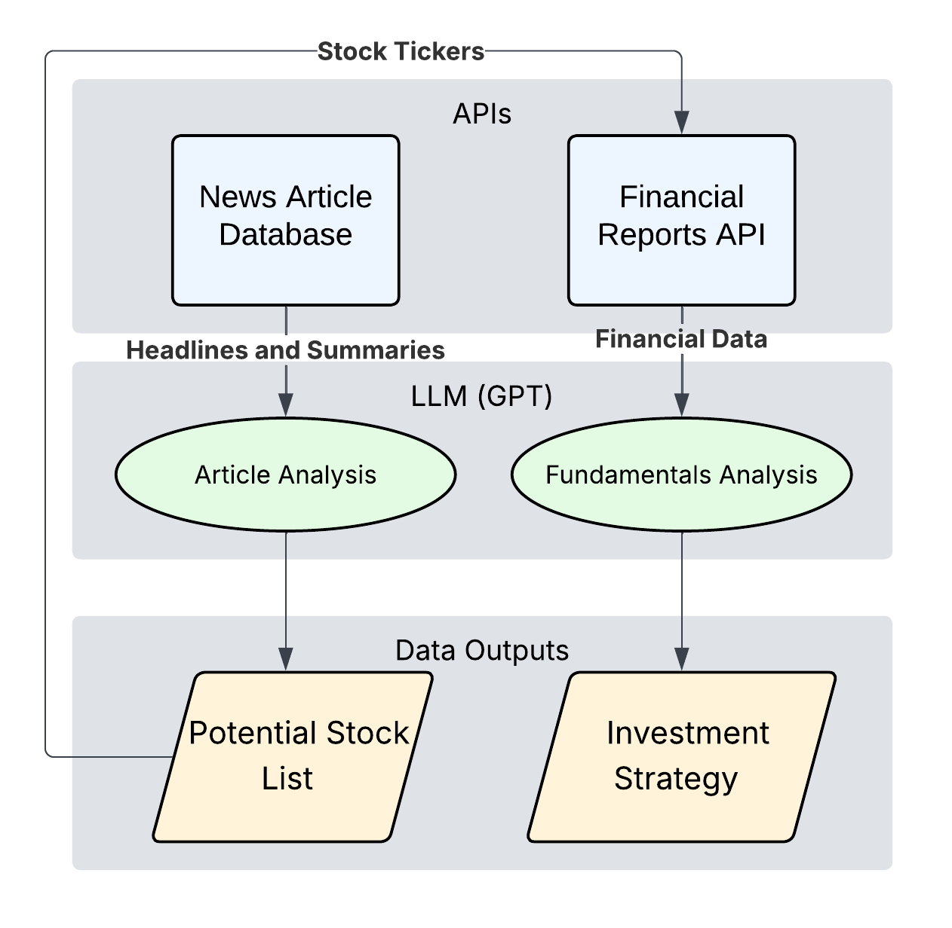

Figure 3.1.1: A Two-Stage Filtering Framework for LLM-Driven Investing

3.1 Overall Framework Overview
This study proposes a structured, multi-stage framework for generating long-term investment strategies using large language models. The overall architecture is illustrated in Figure 3.1.1. The central design principle is that different information sources should be evaluated sequentially rather than simultaneously. Existing LLM-based investment approaches typically provide news articles, financial reports, and other market information within a single reasoning step. While this maximizes information availability, it can also dilute relevant signals and make it more difficult for the model to identify high-quality investment opportunities. The proposed framework instead separates opportunity discovery from financial validation, allowing us to directly evaluate how structural organization of information affects portfolio performance.
The framework consists of four primary phases. First, historical news articles are collected from a fixed pre-analysis window. Second, these articles are used to prompt an LLM to generate a set of candidate stocks with qualitative justifications, constituting Stage One of the framework. Third, financial reports are retrieved for each candidate stock and provided to the LLM in a second analysis stage. The model then evaluates these reports and produces a smaller set of final recommendations. The notation X→Y used throughout this paper denotes this structure: X represents the number of candidate stocks identified during Stage One, while Y represents the number of final investment selections produced after financial-report validation in Stage Two. Finally, the resulting stock selections and allocation weights are used to construct and evaluate a long-only investment portfolio over a predefined investment horizon.
One exception to this general structure is the Ranked configuration. In the other configurations, the LLM is asked to return a fixed number of candidates at each stage. In Ranked, the LLM instead ranks all candidate opportunities without limiting how many it returns; the number is capped to a set value only at the final investment step.
By separating qualitative reasoning—meaning the interpretation of news narratives and financial-report language—from quantitative evaluation—meaning the deterministic calculation of returns, volatility, and benchmark comparisons performed by external code modules—the framework ensures that each component is handled by the tool best suited to it. This separation improves reliability, increases interpretability, and allows performance differences to be attributed directly to specific stages of the investment process.
To evaluate the effect of structural organization of information, multiple filtering configurations were tested, including unfiltered baseline, Ranked, 30→15, 30→10, 30→5, 20→10, 20→5, 10→5, 10→3, and 5→3. Here the unfiltered baseline represents the conventional approach used in much of the existing literature, in which news articles and financial reports are analyzed simultaneously without sequential filtering.

3.2 Data Sources
Three primary categories of data are used in this study: news articles, financial reports, and historical market prices. News data is sourced exclusively from a reputable financial news provider using an application programming interface. All articles are retrieved from dates strictly before the beginning of each evaluation period to prevent future information leakage.
Financial reports are retrieved for each stock that passes Stage One of the two-stage pipeline. These reports provide structured, company-level financial data that the LLM uses in Stage Two to validate and refine the initial candidate list. Like news articles, financial reports are sourced only from dates preceding the evaluation period. (As a comparison, in an unfiltered baseline condition, financial reports for the full union of stocks selected by any pipeline configuration across all runs are provided directly to the LLM alongside all available news articles.)
Market data includes daily adjusted closing prices for individual stocks and benchmark indices. Price data is introduced only after the recommendations have been finalized. This ensures that the reasoning process remains isolated from look-ahead bias and potential computational errors inherent in conventional frameworks where the model processes all input data simultaneously. Consequently, all return calculations and risk metrics are computed externally using deterministic formulas.
To further reduce bias, all experiments enforce strict temporal boundaries. The LLM is provided only with information that would have been available to a real investor at the time of decision-making. This design choice addresses concerns regarding implicit training data leakage and improves the validity of backtesting results.

3.3 News Article Relevance Screening Process
Raw news articles often contain substantial information that is irrelevant to investment decisions, such as opinion pieces, general technology discussions, or political commentary without market implications. To address this issue, a dedicated LLM-based relevance screening step is applied before any strategy generation occurs. Specifically, the LLM is prompted with a constrained classification instruction to label each article as financially relevant or irrelevant—no manual review or rule-based regular expressions are used. This keeps the screening consistent and scalable across all evaluation windows.
In this step, batches of news articles are provided to an LLM with a constrained prompt that instructs the model to select only articles with clear and direct relevance to financial markets. Examples include earnings announcements, major corporate events, regulatory changes, macroeconomic indicators, and industry-level shifts. Articles without a clear investment impact are explicitly excluded.
Screened articles are stored in a curated database and reused for downstream analysis. This approach improves efficiency by allowing a relatively small but high-quality set of inputs to drive the strategy generation process. More importantly, it reduces the likelihood that irrelevant or misleading information influences the model's recommendations.

3.4 LLM-Based Strategy Generation
Once the screened news dataset is constructed, it is used to prompt the LLM to generate investment recommendations. The model is instructed to identify companies that are likely to benefit from the trends and events described in the articles. For each selected stock, the LLM is required to provide a concise justification explaining the reasoning behind the recommendation.
In addition to stock selection, the model assigns a percentage allocation to each recommendation, with the total allocation summing to 100 percent. Constraints are imposed to ensure that the strategy remains long only and suitable for a buy-and-hold investment approach. No leverage, short selling, or reinvestment assumptions are included.
The output of this stage is a structured investment strategy consisting of stock tickers, allocation weights, and qualitative explanations. This structure enables transparency and allows subsequent evaluation without relying on further LLM inference. By requiring explicit justifications, the framework also provides a mechanism for identifying implausible recommendations and mitigating subtle hallucinations.
In the structured two-stage configurations, this stage constitutes Stage One of the two-stage pipeline. Following the X→Y volume tracking established in section 3.1, financial reports are fetched for each of the X candidate stocks and provided to the LLM alongside the original Stage One justifications. The model is then prompted to evaluate each candidate against its corresponding financial report data and produce a final, smaller set of Y recommendations with updated justifications and allocation weights.

3.5 Bias and Hallucination Mitigation
Large language models are known to exhibit hallucinations and implicit bias [42], particularly when prompted with open-ended tasks or incomplete constraints. To mitigate these issues, several safeguards are integrated into the proposed framework.
First, strict temporal constraints are enforced at every stage of the pipeline. All news articles and financial reports provided to the LLM originate from dates strictly preceding the evaluation period, and no market price data is included in any prompt. This design eliminates look-ahead bias because the LLM cannot receive—directly or indirectly—any information about price movements that occurred after the analysis date. Without this constraint, even a subtle mention of a post-analysis event in a news article could allow the model to exploit latent knowledge from pre-training, making retrospective returns appear higher than any real investor could achieve.
Second, the LLM is required to provide explicit qualitative justifications for each stock recommendation. These justifications serve as an internal consistency check, allowing recommendations to be evaluated for plausibility and relevance to the provided data. Recommendations that lack a clear connection to the input information can be identified and excluded from further analysis.
Finally, the framework intentionally restricts the LLM from executing numerical computation or return estimations, delegating all mathematical tasks exclusively to external deterministic modules. This separation reduces the impact of known weaknesses in mathematical reasoning and ensures that hallucinations cannot directly affect performance metrics.

3.6 Portfolio Construction
The investment strategies generated by the LLM are translated into portfolios using a standardized construction process. Each recommended stock is assigned a weight corresponding to the percentage allocation produced by the model, with the total allocation summing to 100 percent.
All portfolios follow a long-only, buy-and-hold structure. No leverage, short selling, or derivatives are permitted, and positions are established at the beginning of the evaluation period and held without rebalancing until the end. This design choice simplifies interpretation and aligns the strategy with realistic long-term investment behavior.
Portfolio values are computed using adjusted closing prices to account for stock splits and dividends. The initial portfolio value is normalized, and returns are calculated based solely on price appreciation over the selected time horizon.

3.7 Permutation Analysis Framework
To evaluate the robustness of the proposed framework, a large-scale permutation analysis was conducted across multiple language models, temperatures, filtering configurations, and evaluation windows. Rather than evaluating a single pipeline configuration under a single market condition, the framework was tested across a broad range of experimental settings to determine whether observed performance trends remained consistent under varying assumptions.
Three language models were evaluated: GPT-4o, GPT-4o-mini, and GPT-5.1. For each model, experiments were conducted using temperatures of 0.3, 0.4, and 0.5. Portfolio recommendations were generated using ten filtering configurations: unfiltered baseline, Ranked, 30→15, 30→10, 30→5, 20→10, 20→5, 10→5, 10→3, and 5→3.
In the X→Y notation used throughout, X is the number of candidate stocks the model proposes in Stage One and Y is the number retained in the final portfolio after Stage-Two validation; the unfiltered baseline selects the portfolio in a single pass, and the Ranked configuration ranks the candidates without imposing a fixed Stage-One cap. We use moderate filtering to mean a configuration built on a mid-sized initial pool — ten or twenty candidates — narrowed to a focused portfolio (for example 20→10, 10→5, 10→3, or 20→5), and aggressive (or over-) filtering to mean a configuration built on an oversized thirty-candidate pool that is then cut steeply, such as 30→5, a six-fold reduction. These labels describe the structural settings only and make no assumption about performance.
Evaluation windows were constructed using rolling 12-month investment horizons. Multiple start dates were selected to expose the framework to different market environments, reducing the likelihood that results were driven by a single favorable period. For each valid combination of model, temperature, filtering configuration, and evaluation window, the complete investment-generation pipeline was executed independently.
Model-specific training-cutoff restrictions were enforced to reduce the risk of lookahead bias influencing our recommendations. Only evaluation windows that satisfied these temporal requirements were included in the final analysis.
The final dataset consisted of 2,759 matched portfolio runs spanning multiple models, temperatures, filtering configurations, and market environments. This design enabled a direct comparison between our structured filtering framework and the corresponding unfiltered baseline under identical experimental conditions.
The matched-permutation framework isolates the effect of structural organization of information by controlling for model capability, temperature, and evaluation window. Consequently, observed performance differences can be confidently attributed to the filtering framework itself rather than confounding variables such as market conditions or model selection.

3.8 Evaluation Methodology
Strategy performance is evaluated using return-based, benchmark-relative, and comparative metrics. The primary performance measure is return on investment (ROI), calculated over fixed 12-month evaluation windows. Portfolio performance is compared against the S&P 500 index over the same period, allowing the calculation of benchmark-relative excess return (alpha).
In addition to absolute performance, baseline win rates are computed between each filtering configuration and the corresponding unfiltered baseline generated using the same language model, temperature, and evaluation window. This metric measures the percentage of evaluation windows in which a filtering configuration produces a higher ROI than the equivalent unstructured approach and provides a direct assessment of whether sequential filtering improves portfolio quality.
To evaluate robustness across market conditions, experiments are conducted across multiple evaluation windows spanning different market environments. This design reduces sensitivity to individual outlier periods and provides a more representative assessment of long-term investment performance.
Portfolio variability is evaluated using standard deviation and coefficient of variation (CV). Standard deviation measures the spread of returns across repeated runs, while CV provides a scale-independent measure of variability relative to average return. Together, these metrics provide a simultaneous evaluation of both performance and structural stability.
Finally, results were aggregated across all models, temperatures, configurations, and evaluation windows to discern broader performance trends and assess the interplay between model capability and the structural organization of information
.

3.9 Statistical Limitations
Multiple configurations share overlapping evaluation windows, source articles, and partially overlapping candidate portfolios. Consequently, observations are not fully independent. Statistical comparisons should therefore be interpreted as indicators of effect magnitude and practical significance rather than fully independent experimental samples. Reported confidence intervals and p-values are approximate and should be treated as heuristic rather than exact.

3.10 Statistical Testing Strategy
To evaluate the significance of observed performance differences, statistical comparisons are conducted across filtering configurations, language models, and experimental factors.
For configuration-level analysis, ROI distributions are grouped according to filtering structure and compared using one-way analysis of variance (ANOVA). When significant differences are detected, post-hoc pairwise comparisons are performed to identify which specific configurations diverge most strongly. Particular attention is paid to contrasting moderate filtering regimes against both aggressive filtering configurations and the unfiltered baseline. Model-level analysis is conducted by grouping results according to the language model used for portfolio generation. Comparisons between GPT-4o, GPT-4o-mini, and GPT-5.1 are used to evaluate the relationship between model capability and investment performance.
In addition to average return comparisons, baseline win rates are analyzed to determine how frequently a filtering configuration outperforms the corresponding unfiltered baseline under identical experimental conditions. Because win rates are computed from matched model-temperature-window combinations, they provide a direct measure of the impact of sequential filtering independent of broader market effects.
Given the non-independence discussed in Section 3.9, statistical tests should be interpreted as indicators of effect magnitude and practical significance rather than fully independent hypothesis tests. Consequently, reported p-values and confidence intervals are best viewed as approximate measures of evidence rather than exact inferential statistics.

4 Results
Key Findings
Structure beats brute force. Structured two-stage filtering raised GPT-5.1's mean ROI to 60.6%, against 45.7% for unfiltered single-pass prompting — a 15-point gain — and beat that baseline in 81% of head-to-head 12-month windows.
There is a clear optimum. Performance follows an inverted-U in the size of the initial candidate pool: a pool of 10–20 candidates performs best, while pools of 5 or 30 underperform.
One simple rule captures it. Make the initial candidate pool about twice the size of the target portfolio — the 2× rule.
Information design rivals model choice. How the model's input was structured affected returns about as much as which model was used.
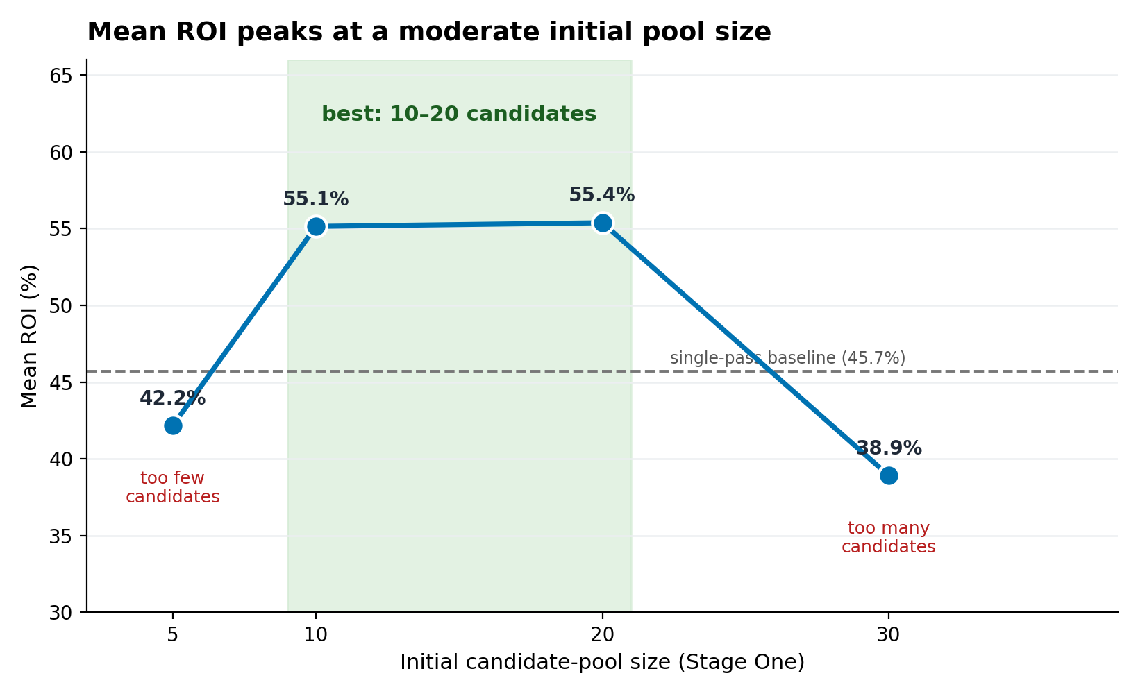
Figure 4.1.1 — The core result. GPT-5.1 mean ROI by initial candidate-pool size: performance peaks for a moderate pool (10–20) and falls below the unfiltered baseline when the model is asked for 30.

4.1 Evaluation Setup
The results presented in this section were generated using three LLM variants—GPT-4o, GPT-4o-mini, and GPT-5.1—within the proposed sequential filtering framework. Performance was evaluated across multiple 12-month investment horizons spanning a range of market conditions. Each evaluation window was treated as an independent experiment.
All configurations were tested at three temperature settings (0.3, 0.4, and 0.5) and across ten portfolio-generation structures: unfiltered, Ranked, 30→15, 30→10, 30→5, 20→10, 20→5, 10→5, 10→3, and 5→3 (Refer to section 3.1 for the definition of these configurations). The final dataset consisted of 2,759 matched portfolio runs spanning multiple models, temperatures, filtering configurations, and evaluation windows. This matched-comparison design enabled direct evaluation of the effect of sequential filtering while controlling for model choice, generation temperature, and market conditions.
Performance was evaluated using return on investment (ROI), alpha relative to the S&P 500 benchmark, standard deviation, coefficient of variation (CV), and matched-comparison win rates against the unfiltered baseline
Before turning to the results, we state the expectation that motivated the configuration sweep: an intermediate initial pool should perform best, because too few candidates limit the choices available to the second stage, while too many force the model to include lower-conviction names. The results that follow test this expectation directly.

4.2 Filtered vs. Unstructured Baseline
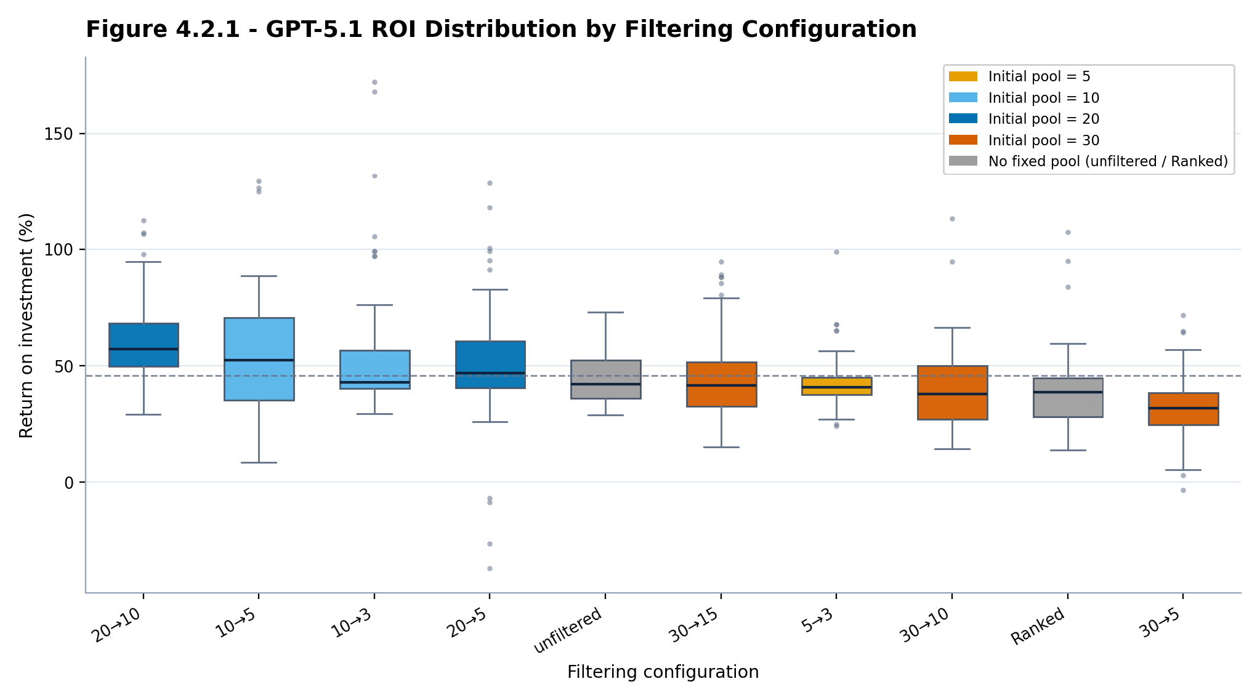

Figure 4.2.1 - Distribution of GPT-5.1 ROI for every filtering configuration, with boxes coloured by initial Stage-One pool size (5, 10, 20, or 30 candidates; grey marks the unfiltered and Ranked methods, which have no fixed pool). All ten configurations are carried through the analysis; the dashed line marks the unfiltered baseline mean. Takeaway: a moderate pool of 10–20 candidates produces the highest returns, while oversized 30-candidate pools fall below the baseline.
Across the three models evaluated, GPT-5.1 was the strongest performer (Section 4.5), so the configuration-, consistency-, and temperature-level analyses in this and the following sections are presented for GPT-5.1; the cross-model comparison that establishes GPT-5.1 as the best model is shown in Figure 4.5.1. Figure 4.2.1 presents the distribution of GPT-5.1's ROI for each filtering configuration. Moderate filtering substantially outperformed the unfiltered baseline: the 20→10 configuration achieved the highest mean ROI (60.6%), followed by 10→5 (56.2%), 10→3 (54.1%), and 20→5 (50.4%), all well above the unfiltered baseline's 45.7%.
Performance declined sharply under aggressive filtering. The four configurations that draw from an oversized thirty-candidate Stage One pool or rank candidates without a validation stage — 30→5 (32.3%), 30→10 (40.1%), 30→15 (44.2%), and Ranked (38.9%) — all underperformed even the unfiltered baseline (45.7%), with the deficit traced below to the oversized Stage-One pool rather than to the final selection step. Although these four methods are dominated on return, all ten configurations are retained and interpreted together in the analyses that follow, each measured against the unfiltered baseline; the weaker methods are shown alongside the others throughout, and the systematic reason for their lower returns is examined below rather than omitted.
What unites these weaker methods is a single setting rather than chance: each one either begins from the oversized thirty-candidate pool (30→15, 30→10, 30→5) or applies no validated reduction at all (Ranked). As we expected, mean ROI traces an inverted-U in the initial pool size (holding the model and evaluation windows fixed) — about 42% at five candidates, 55% at both ten and twenty, and 39% at thirty — so return falls once the starting set grows past the mid-range. The most likely cause is the size of the Stage-One request itself. Asking the model for thirty candidates forces it well past the ten to twenty companies it can identify with genuine conviction; to fill the remaining slots, it nominates marginal names it would not otherwise have proposed. These low-quality additions remain in the candidate set through the second stage and into the final portfolio, where they reduce its overall return. Because the padding originates in Stage One, no choice of final size can undo it — which is why every thirty-candidate configuration trails the baseline regardless of how aggressively it is later narrowed. A smaller pool avoids this by requesting only as many candidates as the model can justify, whereas too small a pool (five) produces the opposite problem, leaving the model too few options from which to construct a strong portfolio.
Overall, Figure 4.2.1 shows that for GPT-5.1 — the most recent and highest-performing of the three models evaluated, and therefore the model a practitioner would deploy — structural organization of information is a major and controllable driver of performance: a moderate pool feeding a focused Stage Two output maximises return, while both under-structuring (the unfiltered baseline) and over-filtering leave achievable return unrealised.
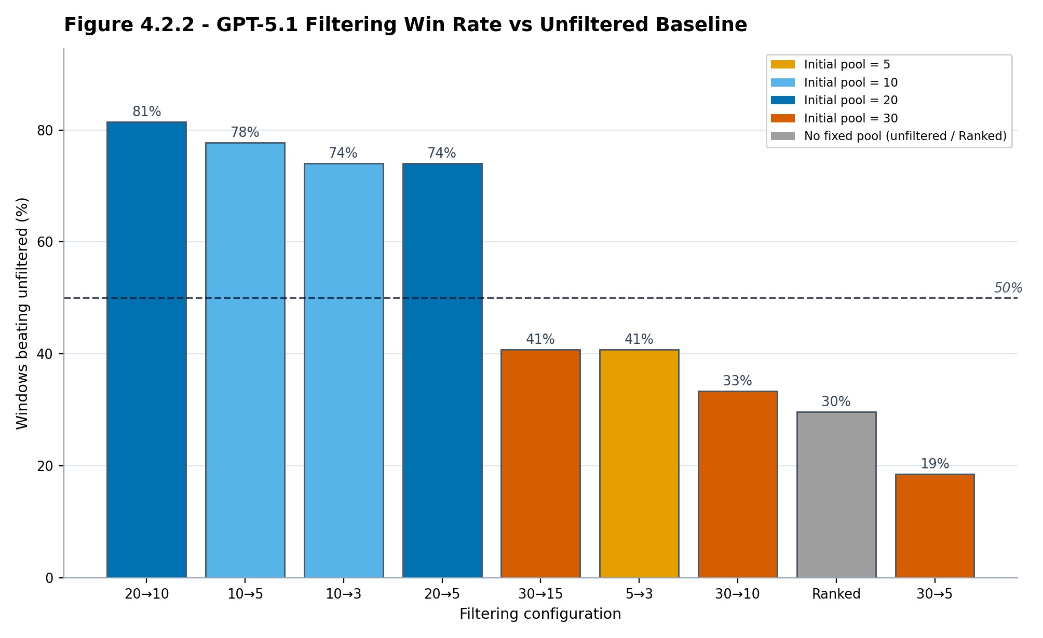

Figure 4.2.2 - Percentage of matched evaluation windows in which each GPT-5.1 filtering configuration outperformed the unfiltered baseline, with bars coloured by initial Stage-One pool size. Takeaway: configurations starting from 10–20 candidates beat the baseline 74–82% of the time, while the 30-candidate configurations and Ranked all fall below 50%.
Configuration | Mean ROI (%) | Win vs Unfiltered (%)
20→10 | 60.6 | 81.5
10→5 | 56.2 | 77.8
10→3 | 54.1 | 74.1
20→5 | 50.4 | 74.1
unfiltered | 45.7 | —
30→15 | 44.2 | 40.7
5→3 | 42.2 | 40.7
30→10 | 40.1 | 33.3
Ranked | 38.9 | 29.6
30→5 | 32.3 | 18.5

Table 1 - GPT-5.1 mean ROI and win rate versus the unfiltered baseline, by filtering configuration (sorted by mean ROI). Full per-configuration statistics for all three models are reported in Appendix A.
To determine whether filtering improved performance under identical conditions, matched-comparison win rates were computed between each configuration and the unfiltered baseline for GPT-5.1, holding temperature and evaluation window fixed.
Filtering substantially improved GPT-5.1's performance. The 20→10 configuration beat the unfiltered baseline in 81.5% of matched windows, followed by 10→5 (77.8%) and 10→3 and 20→5 (both 74.1%). The exception among the competitive set is the highly selective 5→3, which beats the baseline in only 40.7% of windows; it trades return for the lowest run-to-run variability (Section 4.4). The well-sized configurations therefore beat the unfiltered single-pass methodology in roughly three of every four matched windows.
These win rates follow the same two settings, not the identity of any particular configuration. The methods that win most often share a mid-sized initial pool (ten or twenty candidates) narrowed by a moderate, roughly two-to-one ratio — the combination that gives the model enough candidates to rank meaningfully while keeping the final portfolio focused. 5→3 is the informative exception rather than an anomaly: starting from only five candidates, it has too small a pool to reach the top of the return range, so although its tight selection makes it the most stable configuration (Section 4.4), it beats the baseline on return far less often. Initial pool size is therefore the dominant factor — mean return increases from small to mid-sized pools and decreases for oversized ones — and the reduction ratio acts mainly through how aggressively it narrows a given pool.
Taken together, the matched comparisons show that GPT-5.1 reliably benefits from moderate filtering. Because each window is a distinct 12-month holding period, the best-sized configurations’ win rates correspond to outperforming the unfiltered baseline in roughly three of every four years tested.

4.3 Overall Trends
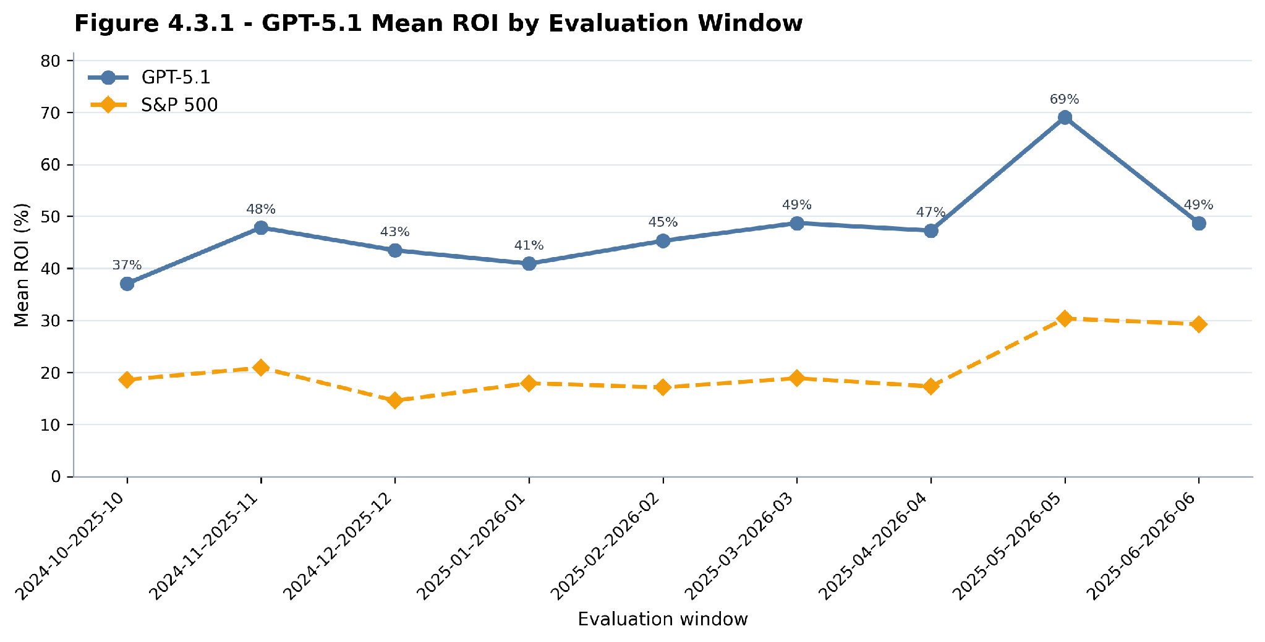

Figure 4.3.1 - GPT-5.1 mean ROI across rolling 12-month evaluation windows, with the corresponding S&P 500 benchmark return. Takeaway: GPT-5.1's mean ROI beat the market in every window (37–69% versus 15–30%).
GPT-5.1's mean ROI exceeded the S&P 500 in every evaluation window tested. Figure 4.3.1 plots its mean ROI across each rolling 12-month window against the benchmark; performance varied with the market environment but stayed above the benchmark throughout.
GPT-5.1's evaluation windows span October 2024 through June 2026; earlier windows are excluded by the model's training-cutoff constraint. The weakest window, October 2024 to October 2025, still returned 37.1%, and the strongest, May 2025 to May 2026, reached 69.0% — roughly double the benchmark in most periods.
The unfiltered baseline also beat the S&P 500 in every window, so this market outperformance reflects model and sector strength rather than the filtering itself; the contribution of the two-stage filtering is isolated in the matched comparison against that baseline (Section 4.2), where the well-sized configurations win in roughly three of four windows. Benchmark returns ranged from approximately 15% to 30%, while GPT-5.1 returned between 37% and 69%, sustaining a large positive margin across all market conditions tested.
Although absolute performance varied across market environments, GPT-5.1 generated consistent positive alpha relative to the benchmark, indicating that the advantage of the sequential filtering approach is not confined to a single favourable market regime.

4.4 Return Variance and Consistency Comparison
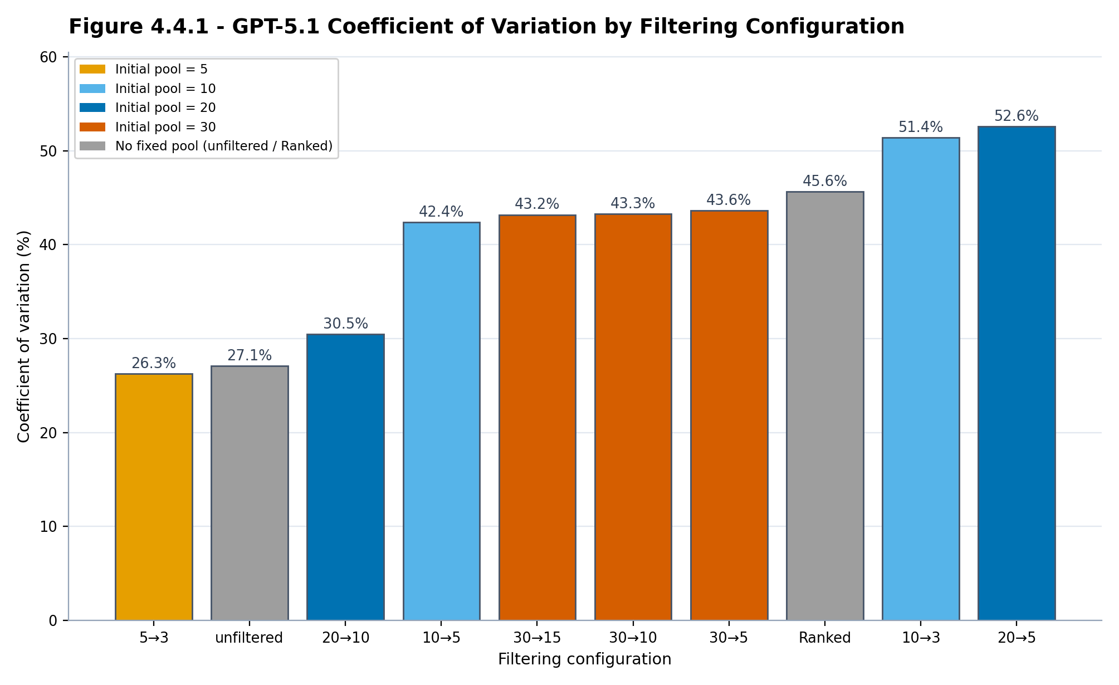

Figure 4.4.1 - GPT-5.1 coefficient of variation (CV) for every filtering configuration, coloured by initial Stage-One pool size; lower values indicate more stable returns. Takeaway: returns are steadiest at the extremes — the most selective configuration (5→3) and the unfiltered baseline — and moderately more variable for the highest-returning configurations.
Filtering also shaped how consistent GPT-5.1's returns were, though not in a simple way: returns were steadiest at both extremes of filtering and more variable in between. Figure 4.4.1 reports the coefficient of variation (CV) for each configuration; lower CV indicates returns that cluster more tightly around the mean.
For GPT-5.1, the most consistent configurations were the highly selective 5→3 (CV 26.3%) and the unfiltered baseline (27.1%), with 20→10 close behind (30.5%). The highest-returning configurations—10→5, 20→5, and 10→3—were moderately less consistent (CV 42–53%). In short, a little more return came with a little more variability.
This consistency ordering is governed by the same settings rather than being incidental. Run-to-run variability is lowest when the second stage is most decisive relative to its input — when the pool is small enough that the final choice is nearly forced (5→3) or when no filtering is imposed at all (the unfiltered baseline) — and highest for the mid-ratio configurations that carry more borderline candidates into the final portfolio. Because stability and return are shaped by the same initial-pool-and-ratio interaction, the return-maximising 20→10 ranks just below the most stable configurations rather than among the most variable, which is what makes it a sensible default.
A note on interpretation: the configuration shapes the average level of return, not the outcome of any single run. Within a given configuration, individual runs vary more than the configurations’ means differ from one another, because most of the run-to-run variation traces to the evaluation window — the prevailing market regime — and to the model’s stochastic re-selection of stocks on each run, rather than to the configuration itself. The configuration effect is therefore assessed through averaged ROI and matched window-by-window win rates, which hold the market regime fixed and let the systematic difference emerge, rather than through the spread of individual runs.
Consistency was therefore not strictly monotonic in filtering strength for GPT-5.1: the single most selective configuration was the most stable, but the highest-returning configurations accepted moderately higher variance in exchange for their return advantage. These findings indicate that filtering shapes not only the level of GPT-5.1's returns but also their distribution, allowing practitioners to trade a portion of return for more consistent, predictable outcomes.

4.5 Model Comparison and Configuration Selection
Two factors determine which configuration to deploy: the underlying model and how the desired portfolio size maps onto the pipeline's two stages. Figure 4.5.1 compares the three models across all filtering configurations that have a fixed pool size, while Table 1, together with the matched win rates of Figure 4.2.2, identifies the best configuration for each target portfolio size. The unfiltered run represents the unfiltered single-pass methodology — the model selecting a portfolio in one step without two-stage filtering — and is the baseline against which every configuration is measured.
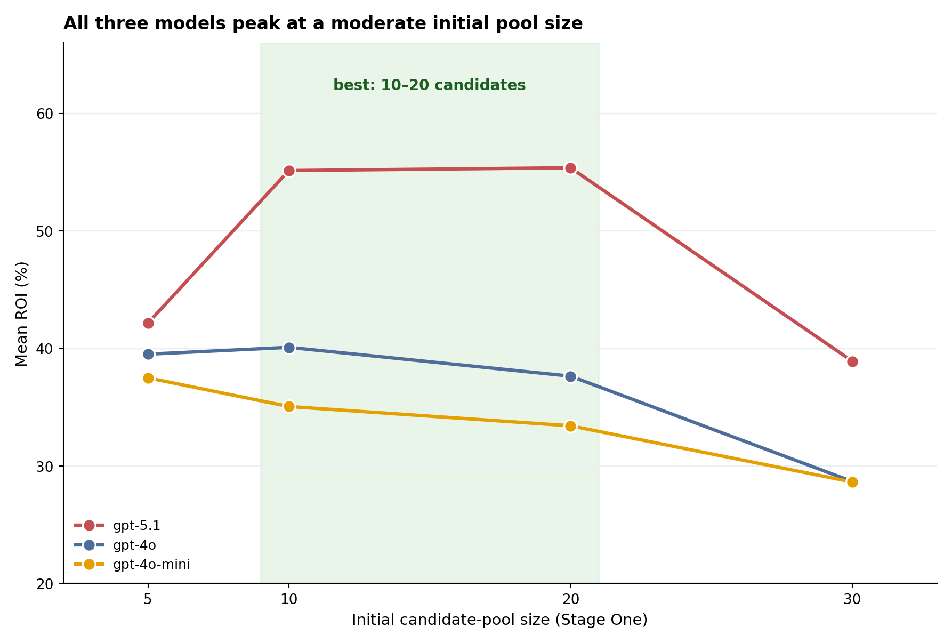

Figure 4.5.1 - Mean ROI by initial candidate-pool size for each model. All three models perform best at a moderate pool of 10–20 candidates and decline for oversized pools, and GPT-5.1 leads at every pool size.
Figure 4.5.1 plots mean ROI against initial candidate-pool size for each of the three models. GPT-5.1 (red) produced the highest ROI at every pool size, averaging 47.0% mean ROI across configurations versus 35.0% for GPT-4o and 32.7% for GPT-4o-mini, a gap of roughly 12 to 14 percentage points that holds across pool sizes. All three models also share the same inverted-U shape, peaking at a moderate pool. This confirms that raw model capability sets the overall return level, while the pipeline configuration determines how much of that level is realised — the strongest results come from pairing the most capable model with an appropriately sized pool.
The same data indicate how the best configuration shifts with the desired portfolio size (Table 1). For a concentrated three-stock portfolio, 10→3 is best (54.1%), beating the unfiltered baseline in 74.1% of matched windows and outperforming the more selective 5→3 (42.2%). For a five-stock portfolio, 10→5 leads (56.2%, beating the baseline 77.8% of the time), ahead of 20→5 (50.4%, 74.1%). For a ten-stock portfolio, 20→10 is both the best option and the single highest-returning configuration in the study (60.6%), beating the baseline in 81.5% of matched windows. A consistent pattern emerges: the best Stage One pool is roughly twice the target portfolio size (the 2× rule). The over-filtered methods identified in Figure 4.2.1 are dominated at every portfolio size and are not recommended.
The reason this pattern holds is the same factor identified in Section 4.2. A Stage One pool of about twice the target size gives the model enough candidates to rank without overwhelming the validation stage; the over-filtered methods — those built on the oversized thirty-candidate pool, such as 30→5 — force the model to nominate low-conviction names that dilute the final portfolio, which is why they trail at every portfolio size. The desired number of holdings thus selects which moderate configuration to use, but it is the moderate regime itself — a mid-sized pool gently narrowed — that produces the return advantage, not the specific label.

4.6 Sector Allocation and Realised Returns
Beyond aggregate returns, the sector composition of GPT-5.1's portfolios shows where its performance originated. Figure 4.6.1 compares each sector's share of the recommended portfolio weight with its share of the realised return. GPT-5.1 allocated the largest share of capital to Mega-Cap Technology (46.9% of weight), yet that sector delivered only 35.5% of realised ROI; Semiconductors, at 26.8% of weight, contributed 54.2% of the realised return — roughly twice their allocation — making them the dominant source of performance. Networking/Infrastructure (8.9% of weight, 6.4% of ROI) and Enterprise SaaS (2.4%, 2.1%) contributed broadly in line with their weights, while a 14.9% allocation to unclassified holdings produced just 1.8% of the realised return. These results indicate that the framework's returns were driven disproportionately by semiconductor selections, and that allocation share alone understates where performance actually originated.

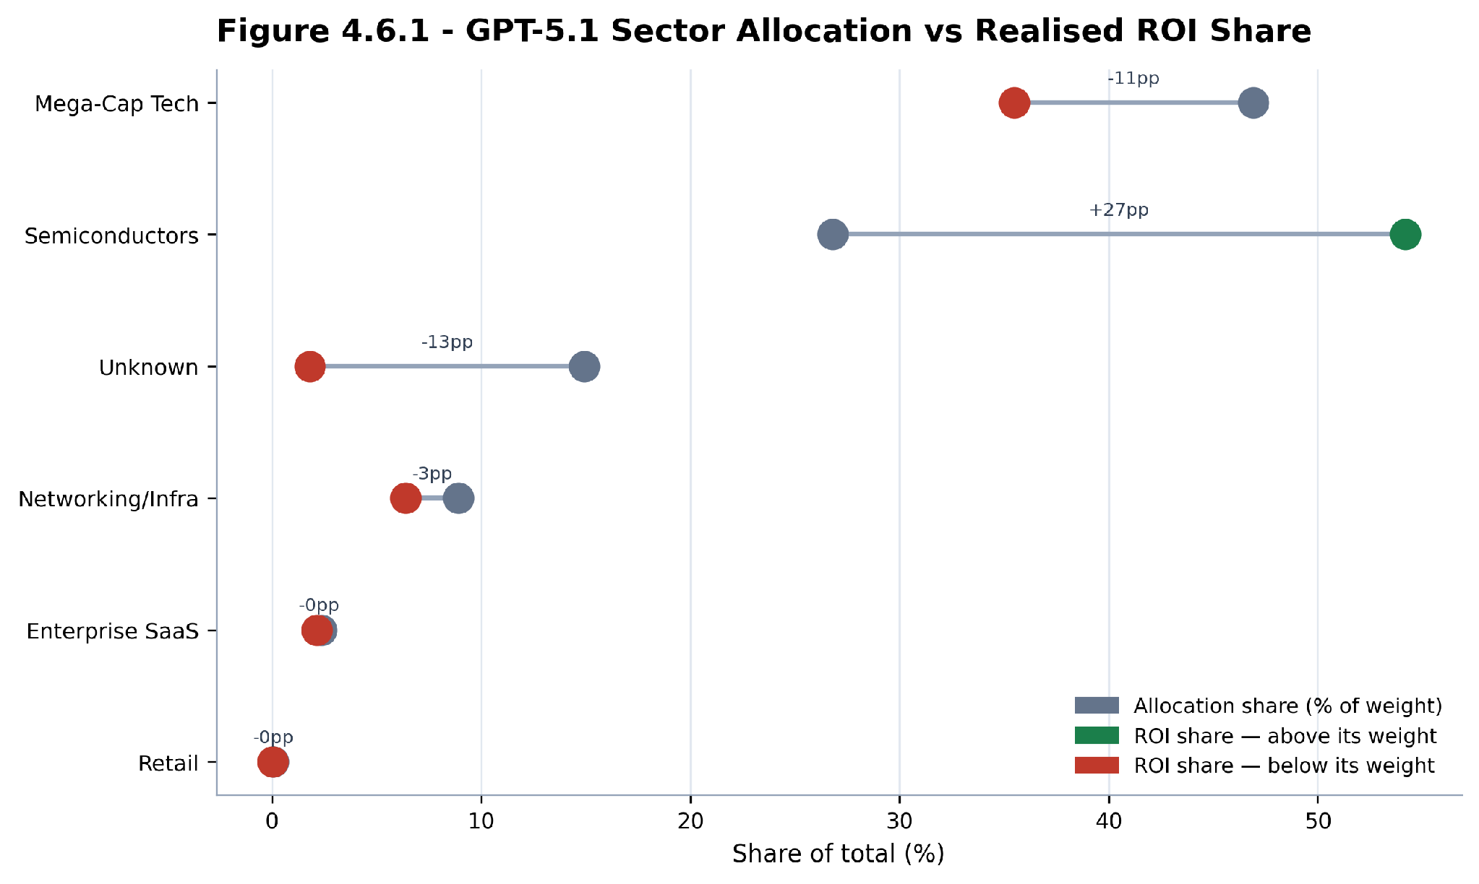

Figure 4.6.1 - GPT-5.1 sector allocation versus realised ROI share. For each sector, the left marker is its share of recommended portfolio weight and the right marker its share of total realised ROI.

5 Discussion

5.1 Interpretation and Implications
The results point to a single, transferable lesson: how the information given to a language model is structured is itself a determinant of investment performance, separate from the choice of model. Presenting the model with a moderate shortlist and asking it to narrow that shortlist — rather than letting it select from an unstructured prompt or forcing it to discard most of an oversized pool — consistently produced the strongest and most reliable returns. Because this gain comes from the design of the pipeline rather than from a larger or newer model, it is available to any practitioner at essentially no additional cost.
The mechanism behind the effect is the size of the first-stage candidate pool. Returns rise and then fall as that pool grows: too few candidates leave the model with too little to choose from, while too many force it to nominate companies beyond those it can justify, filling the candidate list with weak selections that remain in the final portfolio. The practical guideline that follows is simple — begin from a pool of roughly ten to twenty candidates and narrow it by about two to one. The reduction ratio matters mainly through how aggressively it cuts a given pool, and the final portfolio size can then be chosen to match an investor's diversification preference without sacrificing the structural advantage.
These findings also clarify what the framework does and does not establish. Because the unfiltered baseline already beat the market benchmark, the contribution specific to the two-stage design is its consistent improvement over that baseline under matched conditions, not the market outperformance itself. More broadly, the study suggests that for LLM-driven decision systems, deliberate information design is an inexpensive and model-agnostic complement to advances in model scale.

5.2 Limitations and Future Work
Several limitations bound the scope of these findings. All portfolios are long-only and buy-and-hold, and returns are computed without transaction costs, taxes, or slippage, which would modestly reduce realised performance. The investment universe is restricted to a fixed set of large-capitalisation technology and semiconductor equities, so the sector-contribution results in particular may not generalise to broader markets. Because GPT-5.1's evaluation windows are constrained to begin after its training cutoff, its results rest on fewer rolling windows (October 2024 onward) than the older models, and all windows fall within a broadly rising market; performance in a sustained downturn is therefore untested. Finally, the analysis reports raw and benchmark-relative returns together with the coefficient of variation, but does not compute risk-adjusted measures such as the Sharpe or Sortino ratio or maximum drawdown, because the per-portfolio daily return series required for them were not retained.
Future work should address these gaps directly: incorporating transaction-cost and drawdown modelling, extending the universe beyond technology to test sector generalisation, evaluating across bear-market windows as longer post-cutoff histories become available, and adding risk-adjusted performance metrics. Live forward-testing — deploying the recommended configuration prospectively rather than on historical windows — would provide the strongest evidence that the framework's advantage over the unfiltered single-pass methodology persists out of sample.

6 Conclusion
This study set out to test whether structuring the information given to a language model could improve long-term stock selection. Across 2,759 portfolio runs, a two-stage pipeline — using news to assemble a candidate shortlist and financial reports to validate it — reliably outperformed both unfiltered single-pass prompting and aggressive over-filtering. The largest gains came from a moderate design: starting from about ten to twenty candidates and narrowing them by roughly half (the 2× rule) added on the order of fifteen percentage points of mean ROI over the unfiltered baseline and beat it in most matched evaluation windows. The central takeaway is that information design is a distinct and inexpensive determinant of performance in LLM-based investing, comparable in importance to the choice of model. Subject to the limitations above, this points toward a broader direction for LLM agents: treating the structure of a model's inputs as a first-class design variable rather than an afterthought.

Works Cited

[1] An, Siyu, et al. "FinVerse: An Autonomous Agent System for Versatile Financial Analysis." arXiv, 2024, doi:10.48550/arXiv.2406.06379.
[2] Anjum, Khizar, et al. "Domain Specific Benchmarks for Evaluating Multimodal Large Language Models." arXiv, 15 June 2025, doi:10.48550/arXiv.2506.12958.
[3] Blitz, David, et al. "The Term Structure of Machine Learning Alpha." SSRN, 2023, doi:10.2139/ssrn.4474637.
[4] Cao, Bokai, et al. "From Deep Learning to LLMs: A Survey of AI in Quantitative Investment." arXiv, 27 Mar. 2025, doi:10.48550/arXiv.2503.21422.
[5] Cheng, Junyan, and Peter Chin. "AAPM: Large Language Model Agent-Based Asset Pricing Models." arXiv, 2024, doi:10.48550/arXiv.2409.17266.
[6] Choi, Chanyeol, et al. "Structuring the Unstructured: A Multi-Agent System for Extracting and Querying Financial KPIs and Guidance." arXiv, 2025, doi:10.48550/arXiv.2505.19197.
[7] Ding, Han, et al. "Large Language Model Agent in Financial Trading: A Survey." arXiv, 2024, doi:10.48550/arXiv.2408.06361.
[8] Fatemi, Sorouralsadat, and Yuheng Hu. "Enhancing Financial Question Answering with a Multi-Agent Reflection Framework." Proceedings of the 5th ACM International Conference on AI in Finance, 2024.
[9] Fatouros, George, et al. "MarketSenseAI 2.0: Enhancing Stock Analysis through LLM Agents." arXiv, 2025, doi:10.48550/arXiv.2502.00415.
[10] Fazlija, Bledar, et al. "Implementing Financial Regulations Using Large Language Models." SSRN, 2024.
[11] Guo, Taian, et al. "MASS: Multi-Agent Simulation Scaling for Portfolio Construction." arXiv, 2025, doi:10.48550/arXiv.2505.10278.
[12] Guo, Taicheng, et al. "Large Language Model Based Multi-Agents: A Survey of Progress and Challenges." arXiv, 2024, doi:10.48550/arXiv.2402.01680.
[13] Han, Xuewen, et al. "Enhancing Investment Analysis: Optimizing AI-Agent Collaboration in Financial Research." ACM International Conference on AI in Finance, 2024.
[14] Joshi, Satyadhar. "A Comprehensive Review of Gen AI Agents: Applications and Frameworks in Finance, Investments and Risk Domains." International Journal of Innovative Science and Research Technology, 2025.
[15] Joshi, Satyadhar. "A Literature Review of Gen AI Agents in Financial Applications: Models and Implementations." SSRN 5133985, 2025.
[16] Kou, Zhizhuo, et al. "Automate Strategy Finding with LLM in Quantitative Investment." arXiv, 2024, doi:10.48550/arXiv.2409.06289.
[17] Lee, Jean, et al. "A Survey of Large Language Models in Finance (FinLLMs)." Neural Computing and Applications, vol. 37, 2024, pp. 24853–24867, doi:10.48550/arXiv.2402.02315.
[18] Li, Haohang, et al. "InvestorBench: A Benchmark for Financial Decision-Making Tasks with LLM-Based Agents." arXiv, 2024, doi:10.48550/arXiv.2412.18174.
[19] Li, Jinzheng, et al. "An Agent Framework for Real-Time Financial Information Searching with Large Language Models." arXiv, 2025, doi:10.48550/arXiv.2502.15684.
[20] Li, Weixian Waylon, et al. "Can LLM-Based Financial Investing Strategies Outperform the Market in the Long Run?" arXiv, 2025, doi:10.48550/arXiv.2505.07078.
[21] Li, Nian, et al. "EconAgent: Large Language Model-Empowered Agents for Simulating Macroeconomic Activities." arXiv, 2023, doi:10.48550/arXiv.2310.10436.
[22] Li, Yang, et al. "TradingGPT: Multi-Agent System with Layered Memory and Distinct Characters for Enhanced Financial Trading Performance." arXiv, 2023, doi:10.48550/arXiv.2309.03736.
[23] Lopez-Lira, Alejandro. "Can Large Language Models Trade? Testing Financial Theories with LLM Agents in Market Simulations." arXiv, 2025, doi:10.48550/arXiv.2504.10789.
[24] Lopez-Lira, Alejandro, and Yuehua Tang. "Can ChatGPT Forecast Stock Price Movements? Return Predictability and Large Language Models." SSRN, 2023, doi:10.2139/ssrn.4412788.
[25] Lu, Guang, and Sylvia B. Larcher. "Hybrid Long Document Summarization Using C2F-FAR and ChatGPT: A Practical Study." arXiv, 2023, doi:10.48550/arXiv.2306.01169.
[26] Luo, Junyu, et al. "Large Language Model Agent: A Survey on Methodology, Applications and Challenges." arXiv, 2025, doi:10.48550/arXiv.2503.21460.
[27] Mirzadeh, Iman, et al. "GSM-Symbolic: Understanding the Limitations of Mathematical Reasoning in Large Language Models." International Conference on Learning Representations (ICLR 2025), 2025, doi:10.48550/arXiv.2410.05229.
[28] Naveed, Humza, et al. "A Comprehensive Overview of Large Language Models." ACM Transactions on Intelligent Systems and Technology, 2023.
[29] Nie, Yuqi, et al. "A Survey of Large Language Models for Financial Applications: Progress, Prospects and Challenges." arXiv, 2024, doi:10.48550/arXiv.2406.11903.
[30] Okpala, Izunna, et al. "Agentic AI Systems Applied to Tasks in Financial Services: Modeling and Model Risk Management Crews." arXiv, 2025, doi:10.48550/arXiv.2502.05439.
[31] Sapkota, Ranjan, et al. "AI Agents vs. Agentic AI: A Conceptual Taxonomy, Applications, and Challenges." arXiv, 2025, doi:10.48550/arXiv.2505.10468.
[32] Takayanagi, Takehiro, et al. "Are Generative AI Agents Effective Personalized Financial Advisors?" arXiv, 2025, doi:10.48550/arXiv.2504.05862.
[33] Takayanagi, Takehiro, et al. "FinPersona: An LLM-Driven Conversational Agent for Personalized Financial Advising." European Conference on Information Retrieval, 2025.
[34] Tetlock, Paul C. "Giving Content to Investor Sentiment: The Role of Media in the Stock Market." Journal of Finance, vol. 62, no. 3, 2007, pp. 1139–1168.
[35] Vidler, Alicia, and Toby Walsh. "Shifting Power: Leveraging LLMs to Simulate Human Aversion in ABMs of Bilateral Financial Exchanges." arXiv, 2025, doi:10.48550/arXiv.2503.00320.
[36] Wang, Saizhuo, et al. "QuantAgent: Seeking the Holy Grail in Trading by Self-Improving Large Language Models." arXiv, 2024, doi:10.48550/arXiv.2402.03755.
[37] Xiao, Yijia, et al. "TradingAgents: Multi-Agents LLM Financial Trading Framework." arXiv, 2024, doi:10.48550/arXiv.2412.20138.
[38] Yu, Yangyang, et al. "FinMem: A Performance-Enhanced LLM Trading Agent with Layered Memory and Character Design." AAAI Symposium Series, 2024.
[39] Yuan, Hang, et al. "Alpha-GPT 2.0: Human-in-the-Loop AI for Quantitative Investment." arXiv, 2024, doi:10.48550/arXiv.2402.09746.
[40] Zhang, Chong, et al. "When AI Meets Finance (StockAgent): Large Language Model-Based Stock Trading in Simulated Real-World Environments." arXiv, 2024, doi:10.48550/arXiv.2407.18957.
[41] Zhang, Wentao, et al. "A Multimodal Foundation Agent for Financial Trading: Tool-Augmented, Diversified, and Generalist." ACM SIGKDD Conference on Knowledge Discovery and Data Mining, 2024.
[42] Zhang, Yue, et al. "Siren’s Song in the AI Ocean: A Survey on Hallucination in Large Language Models." Computational Linguistics, MIT Press, 2025, doi:10.48550/arXiv.2309.01219.
[43] Zhao, Tianjiao, et al. "AlphaAgents: Large Language Model-Based Multi-Agents for Equity Portfolio Constructions." arXiv, 2025, doi:10.48550/arXiv.2508.11152.
[44] Zhou, Tianyu, et al. "FinRobot: AI Agent for Equity Research and Valuation with Large Language Models." arXiv, 2024, doi:10.48550/arXiv.2411.08804.
[45] Chen, Kefan, et al. "3S-Trader: A Multi-LLM Framework for Adaptive Stock Scoring, Strategy, and Selection in Portfolio Optimization." arXiv, 2025, doi:10.48550/arXiv.2510.17393.

Appendix A Full Per-Configuration Results
This appendix reports the complete per-configuration statistics underlying the analysis in Section 4, for all three language models. For each model and filtering configuration it lists the number of matched runs (n), the mean, median, standard deviation, coefficient of variation, and minimum and maximum return on investment, together with the mean alpha versus the S&P 500, the share of runs that beat the S&P 500, and the win rate against the unfiltered baseline. Win rate is undefined for the unfiltered baseline itself.
GPT-5.1
Config | n | Mean ROI | Median | Std | CV % | Min | Max | Alpha (pp) | Beat S&P % | Win %
20→10 | 70 | 60.6 | 57.0 | 18.5 | 30.5 | 28.9 | 112.4 | 40.8 | 100.0 | 81.5
10→5 | 71 | 56.2 | 52.4 | 23.8 | 42.4 | 8.4 | 129.2 | 36.6 | 98.6 | 77.8
10→3 | 71 | 54.1 | 42.9 | 27.8 | 51.4 | 29.4 | 172.2 | 34.4 | 100.0 | 74.1
20→5 | 73 | 50.4 | 46.9 | 26.5 | 52.6 | -37.3 | 128.5 | 30.7 | 94.5 | 74.1
unfiltered | 27 | 45.7 | 41.9 | 12.4 | 27.1 | 28.8 | 72.9 | 25.0 | 100.0 | —
30→15 | 63 | 44.2 | 41.5 | 19.1 | 43.2 | 15.0 | 94.6 | 23.7 | 98.4 | 40.7
5→3 | 71 | 42.2 | 40.7 | 11.1 | 26.3 | 24.1 | 98.8 | 22.5 | 100.0 | 40.7
30→10 | 62 | 40.1 | 37.7 | 17.4 | 43.3 | 14.2 | 113.1 | 19.6 | 93.5 | 33.3
Ranked | 56 | 38.9 | 38.5 | 17.7 | 45.6 | 13.8 | 107.3 | 18.2 | 91.1 | 29.6
30→5 | 62 | 32.3 | 31.7 | 14.1 | 43.6 | -3.5 | 71.5 | 11.9 | 88.7 | 18.5
GPT-4o
Config | n | Mean ROI | Median | Std | CV % | Min | Max | Alpha (pp) | Beat S&P % | Win %
20→10 | 99 | 35.1 | 32.7 | 18.6 | 52.9 | 3.1 | 123.0 | 16.5 | 87.9 | 53.8
10→5 | 107 | 40.0 | 41.1 | 24.4 | 60.9 | -8.7 | 128.6 | 21.4 | 84.1 | 61.5
10→3 | 104 | 40.2 | 42.0 | 18.9 | 47.0 | 9.1 | 177.0 | 21.6 | 92.3 | 76.9
20→5 | 108 | 39.9 | 39.5 | 24.3 | 60.9 | -5.3 | 177.7 | 21.4 | 84.3 | 66.7
unfiltered | 39 | 34.9 | 33.3 | 15.8 | 45.4 | 6.1 | 74.3 | 15.6 | 89.7 | —
30→15 | 90 | 28.9 | 26.4 | 11.8 | 41.0 | 9.2 | 56.2 | 10.1 | 81.1 | 35.9
5→3 | 108 | 39.5 | 42.1 | 24.3 | 61.6 | -3.1 | 177.0 | 21.0 | 80.6 | 59.0
30→10 | 87 | 26.7 | 25.7 | 10.5 | 39.2 | 5.2 | 56.6 | 8.5 | 82.8 | 33.3
Ranked | 94 | 30.5 | 32.6 | 11.5 | 37.6 | 6.5 | 49.7 | 11.6 | 81.9 | 35.9
30→5 | 85 | 30.5 | 30.6 | 11.8 | 38.8 | 9.4 | 62.4 | 11.4 | 88.2 | 35.9
GPT-4o-mini
Config | n | Mean ROI | Median | Std | CV % | Min | Max | Alpha (pp) | Beat S&P % | Win %
20→10 | 124 | 28.9 | 28.3 | 10.2 | 35.4 | 9.7 | 61.3 | 10.4 | 91.9 | 15.4
10→5 | 131 | 36.3 | 37.4 | 16.2 | 44.7 | -7.2 | 113.9 | 17.8 | 86.3 | 53.8
10→3 | 121 | 33.8 | 35.2 | 10.2 | 30.1 | 9.0 | 52.0 | 15.3 | 93.4 | 35.9
20→5 | 132 | 37.7 | 34.5 | 19.3 | 51.3 | -0.1 | 133.6 | 19.2 | 96.2 | 46.2
unfiltered | 42 | 38.4 | 37.6 | 14.9 | 38.9 | 9.5 | 83.5 | 19.4 | 97.6 | —
30→15 | 138 | 33.7 | 31.3 | 12.6 | 37.5 | 8.0 | 66.1 | 15.1 | 96.4 | 38.5
5→3 | 129 | 37.5 | 40.5 | 18.5 | 49.3 | -8.7 | 146.2 | 19.0 | 82.2 | 53.8
30→10 | 138 | 25.9 | 24.6 | 9.5 | 36.8 | 6.7 | 60.4 | 7.5 | 88.4 | 10.3
Ranked | 138 | 32.4 | 34.9 | 9.4 | 28.9 | 2.2 | 48.8 | 13.7 | 92.8 | 25.6
30→5 | 119 | 25.9 | 25.8 | 11.1 | 42.8 | 4.7 | 60.7 | 7.2 | 82.4 | 7.7

